Data Structures and Algorithms Basics
- What is Big O notation, and how does it help in analyzing the performance of algorithms?
- What is the difference between Big O, Big Theta (Θ), and Big Omega (Ω) notations?
- What are the time complexity and space complexity?
- What are the time complexities and space complexities for common operations in data structures (e.g., arrays, linked lists, stacks, queues)?
- How do nested loops and recursion impact time complexity?
- What are the Big O notations for the following complexities: (Constant time (O(1)), Logarithmic time (O(log n)), Linear time (O(n)), Quadratic time (O(n²)), Cubic time (O(n³)), Exponential time (O(2^n)))

What is Big O notation, and how does it help in analyzing the performance of algorithms?
Big O notation is a mathematical tool used to describe the upper bound of an algorithm's runtime or space complexity. It provides a way to understand the efficiency of an algorithm, particularly how the runtime or space requirements grow as the input size increases.

How Big O Notation Helps:
- Understanding Growth Rates: Big O notation provides insight into how an algorithm's performance scales with input size. For example:
  - An algorithm with O(n) complexity scales linearly with the input size nnn,
  - While an algorithm with O(n^2) scales quadratically. This helps in comparing different algorithms' performances as the input grows.
- Ignoring Constants: Big O focuses on the dominant term, ignoring constant factors and lower-order terms. This allows comparisons of algorithms based on their overall growth patterns rather than implementation-specific details or hardware differences.
- Worst-Case Scenario: Big O typically describes the worst-case scenario, ensuring the algorithm does not exceed a certain performance limit regardless of the input.
- Algorithm Comparison: Using Big O notation enables you to compare the efficiency of different algorithms and select the most suitable one based on input size and constraints.

Common Big O Notations:
- O(1): Constant time – The algorithm's runtime is fixed and does not depend on the input size.
- O(log n): Logarithmic time – The runtime grows logarithmically as the input size increases.
- O(n): Linear time – The runtime grows linearly with the input size.
- O(n log n): Linearithmic time – The runtime grows proportionally to nlog⁡nn \log nnlogn.
- O(n^2): Quadratic time – The runtime grows quadratically with the input size.
- O(2^n): Exponential time – The runtime doubles with each additional input element.
- O(n!): Factorial time – The runtime grows factorially as the input size increases.
By understanding Big O notation, you can better assess and optimize algorithms to ensure they perform efficiently for various input sizes and use cases.
//////////////////////////////////////////////////////////////////////////////////////////////////////////////////////

What is the difference between Big O, Big Theta (Θ), and Big Omega (Ω) notations?
Big O, Big Theta (Θ), and Big Omega (Ω) notations are used to describe the performance characteristics of algorithms, but they serve different purposes:

1. Big O Notation (O)
- Definition: Big O provides an upper bound on the time or space complexity of an algorithm. It describes the worst-case scenario, showing how the runtime or space requirements grow relative to the input size.
- Usage: It is used to describe the maximum time or space an algorithm will require. For example, if an algorithm is said to run in O(n²) time, it means that in the worst case, its runtime will grow quadratically with the input size.
- Formal Definition: An algorithm is O(f(n)) if there exist positive constants ccc and n0n_0n0​ such that for all n≥n0n \geq n_0n≥n0​, the runtime T(n)≤c⋅f(n)T(n) \leq c \cdot f(n)T(n)≤c⋅f(n).

2. Big Theta Notation (Θ)
- Definition: Big Theta provides both an upper and lower bound on the time or space complexity. It describes the exact asymptotic behavior of the algorithm, bounding it from both above and below.
- Usage: It is used when you want to express the exact growth rate of an algorithm. If an algorithm is Θ(n²), it means its runtime grows quadratically with the input size in both best and worst cases.
- Formal Definition: An algorithm is Θ(f(n)) if there exist positive constants c1c_1c1​, c2c_2c2​, and n0n_0n0​ such that for all n≥n0n \geq n_0n≥n0​, c1⋅f(n)≤T(n)≤c2⋅f(n)c_1 \cdot f(n) \leq T(n) \leq c_2 \cdot f(n)c1​⋅f(n)≤T(n)≤c2​⋅f(n).

3. Big Omega Notation (Ω)
- Definition: Big Omega provides a lower bound on the time or space complexity. It describes the best-case scenario, showing the minimum time or space the algorithm will take.
- Usage: It is used to express the minimum time or space an algorithm requires. For instance, if an algorithm is Ω(n), its runtime will grow at least linearly with the input size.
- Formal Definition: An algorithm is Ω(f(n)) if there exist positive constants ccc and n0n_0n0​ such that for all n≥n0n \geq n_0n≥n0​, T(n)≥c⋅f(n)T(n) \geq c \cdot f(n)T(n)≥c⋅f(n).

Summary
- Big O (O): Describes the upper bound (worst-case scenario).
- Big Theta (Θ): Describes the exact bound, providing both upper and lower bounds.
- Big Omega (Ω): Describes the lower bound (best-case scenario).
These notations help in understanding and comparing the efficiency of algorithms in terms of their growth rates and performance.
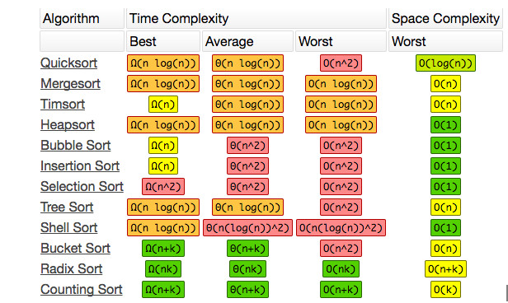
//////////////////////////////////////////////////////////////////////////////////////////////////////////////////////

What are the time complexity and space complexity?

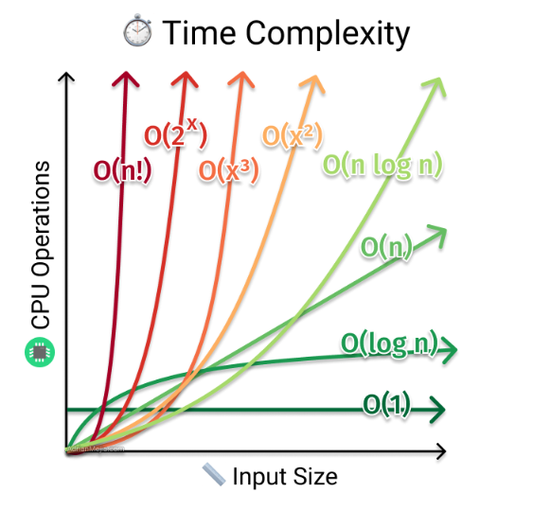
Time complexity and space complexity are two fundamental metrics used to analyze the efficiency of an algorithm:

1. Time Complexity
- Definition: Time complexity measures the amount of time an algorithm takes to complete as a function of the input size. It helps in understanding how the runtime of an algorithm increases with larger inputs.
- Purpose: To estimate how the runtime grows relative to the input size and to compare the efficiency of different algorithms.
- Common Classes:
  - Constant Time (O(1)): The algorithm's runtime does not change with the input size.
  - Logarithmic Time (O(log n)): The runtime grows logarithmically with the input size.
  - Linear Time (O(n)): The runtime grows linearly with the input size.
  - Linearithmic Time (O(n log n)): The runtime grows proportionally to nlog⁡nn \log nnlogn.
  - Quadratic Time (O(n^2)): The runtime grows quadratically with the input size.
  - Exponential Time (O(2^n)): The runtime grows exponentially with the input size.
  - Factorial Time (O(n!)): The runtime grows factorially with the input size.

2. Space Complexity
- Definition: Space complexity measures the amount of memory an algorithm uses as a function of the input size. It helps in understanding how the space requirements of an algorithm increase with larger inputs.
- Purpose: To estimate the memory usage of an algorithm and to compare the efficiency of different algorithms in terms of space.
- Common Classes:
  - Constant Space (O(1)): The algorithm uses a fixed amount of memory regardless of the input size.
  - Linear Space (O(n)): The memory usage grows linearly with the input size.
  - Quadratic Space (O(n^2)): The memory usage grows quadratically with the input size.

Key Differences
- Time Complexity: Focuses on the duration an algorithm takes to complete. It is concerned with execution time and how it scales with the input size.
- Space Complexity: Focuses on the amount of memory an algorithm requires. It is concerned with storage requirements and how they scale with the input size.

Example
For a simple example, consider a function that calculates the sum of an array:
public int SumArray(int[] array) {
int sum = 0; // Constant space
for (int i = 0; i < array.Length; i++) { // Linear time complexity
sum += array[i];
}
return sum;
}
- Time Complexity: O(n) because the function iterates through the array once, and the runtime grows linearly with the size of the array.
- Space Complexity: O(1) because the function uses a fixed amount of additional space (the sum variable), regardless of the size of the array.
Understanding both time and space complexity helps in evaluating the efficiency of algorithms and making trade-offs between performance and resource usage.
//////////////////////////////////////////////////////////////////////////////////////////////////////////////////////

What are the time complexities for common operations in data structures (e.g., arrays, linked lists, stacks, queues)?
Here's a summary of time and space complexities for common operations in various data structures:

1. Arrays
- Access:
  - Time Complexity: O(1) (direct index access is constant time)
  - Space Complexity: O(n) (space for the array of size nnn)
- Search:
  - Time Complexity: O(n) (linear search in an unsorted array), O(log n) (binary search in a sorted array)
  - Space Complexity: O(1) (space for the search operation)
- Insertion:
  - Time Complexity: O(n) (inserting at a specific position requires shifting elements)
  - Space Complexity: O(n) (space for the array of size nnn)
- Deletion:
  - Time Complexity: O(n) (deleting at a specific position requires shifting elements)
  - Space Complexity: O(n) (space for the array of size nnn)

2. Linked Lists
- Access:
  - Time Complexity: O(n) (linear search required to access a specific node)
  - Space Complexity: O(1) (space for accessing elements)
- Search:
  - Time Complexity: O(n) (requires traversing the list)
  - Space Complexity: O(1) (space for the search operation)
- Insertion:
  - Time Complexity: O(1) (if inserting at the head or tail with a known reference)
  - Space Complexity: O(1) (space for the new node)
- Deletion:
  - Time Complexity: O(1) (if deleting a known node with a reference)
  - Space Complexity: O(1) (space for the operation)

3. Stacks
- Push:
  - Time Complexity: O(1) (constant time for adding an element to the top)
  - Space Complexity: O(1) (space for the stack itself)
- Pop:
  - Time Complexity: O(1) (constant time for removing the top element)
  - Space Complexity: O(1) (space for the operation)
- Peek:
  - Time Complexity: O(1) (constant time for accessing the top element)
  - Space Complexity: O(1) (space for the operation)

4. Queues
- Enqueue:
  - Time Complexity: O(1) (constant time for adding an element to the rear)
  - Space Complexity: O(1) (space for the queue itself)
- Dequeue:
  - Time Complexity: O(1) (constant time for removing the front element)
  - Space Complexity: O(1) (space for the operation)
- Peek/Front:
  - Time Complexity: O(1) (constant time for accessing the front element)
  - Space Complexity: O(1) (space for the operation)

Summary
- Arrays: Fast access but costly insertion and deletion.
- Linked Lists: Fast insertion and deletion but costly access.
- Stacks: Constant time operations for push, pop, and peek.
- Queues: Constant time operations for enqueue, dequeue, and peek.
Understanding these complexities helps in choosing the right data structure based on the requirements of the problem and the type of operations that are most frequently performed.
//////////////////////////////////////////////////////////////////////////////////////////////////////////////////////

How do nested loops and recursion impact time complexity?

1. Nested Loops
Nested loops occur when one loop is placed inside another. The overall time complexity of nested loops is the product of the complexities of the individual loops.
- Single Loop: A single loop that runs n times has a time complexity of O(n).
for (int i = 0; i < n; i++) {
// Constant time operation
}
The loop runs nnn times, so the time complexity is O(n).
- Two Nested Loops: If you have two nested loops, each running n times, the time complexity becomes O(n²).
for (int i = 0; i < n; i++) {
for (int j = 0; j < n; j++) {
// Constant time operation
}
}
The inner loop runs n times for each iteration of the outer loop, resulting in n×n= n² operations, so the time complexity is O(n²).
- Three Nested Loops: If you have three nested loops, each running n times, the time complexity becomes O(n³).
for (int i = 0; i < n; i++) {
for (int j = 0; j < n; j++) {
for (int k = 0; k < n; k++) {
// Constant time operation
}
}
}
The total number of operations is n×n×n= n³, so the time complexity is O(n³).
- General Case: If you have k nested loops, each running n times, the time complexity is O(n^k).

2. Recursion
The time complexity of recursive algorithms depends on the number of recursive calls and the work done at each level.
- Linear Recursion: If a recursive function makes a single recursive call and does constant work at each level, the time complexity is O(n).
int sum(int n) {
if (n <= 1) return n;
return n + sum(n - 1);
}
This function is called n times, so the time complexity is O(n).
- Binary Recursion: If a recursive function makes two recursive calls per level (as in binary search or merge sort), the time complexity differs depending on the algorithm:
  - Binary Search: Time complexity is O(log n), since the input size is halved at each recursive step.
  - Merge Sort: Time complexity is O(n \log n) because the array is split into halves (logarithmic factor) and the merging step takes linear time.
Merge Sort Example:

void mergeSort(int[] arr) {
if (arr.length < 2) return;
int mid = arr.length / 2;
int[] left = Arrays.copyOfRange(arr, 0, mid);
int[] right = Arrays.copyOfRange(arr, mid, arr.length);
mergeSort(left);
mergeSort(right);
merge(left, right, arr);
}
Merge sort splits the array into two halves recursively (logarithmic factor) and merges the sorted halves (linear factor), resulting in O(n \log n) complexity.
- Exponential Recursion: If each recursive call generates multiple recursive calls, the time complexity can become exponential. For example, in the naive Fibonacci sequence calculation:
int fibonacci(int n) {
if (n <= 1) return n;
return fibonacci(n - 1) + fibonacci(n - 2);
}
Each call to fibonacci(n) makes two further recursive calls, leading to a time complexity of O(2^n).

Summary:
- Nested Loops: For k nested loops, each running n times, the time complexity is O(n^k).
- Recursion: Time complexity depends on the structure of the recursion:
  - Linear Recursion: O(n) for one recursive call per level.
  - Binary Recursion: O(log n) for binary search, O(n \log n) for merge sort.
  - Exponential Recursion: O(2^n) for exponential recursion like naive Fibonacci sequence.
Understanding these time complexities is essential for analyzing and optimizing algorithms efficiently.
//////////////////////////////////////////////////////////////////////////////////////////////////////////////////////
What are the Big O notations for the following complexities: (Constant time (O(1)), Logarithmic time (O(log n)), Linear time (O(n)), Quadratic time (O(n²)), Cubic time (O(n³)), Exponential time (O(2^n)))
Here are the Big O notations for the specified complexities:

1. Constant Time (O(1))
- Notation: O(1)
- Description: The algorithm's runtime or space requirement remains constant regardless of the input size nnn. The execution time does not change as the input grows.
  - Example: Accessing an element in an array by index.

2. Logarithmic Time (O(log n))
- Notation: O(log n)
- Description: The runtime grows logarithmically with the input size. Algorithms that repeatedly divide the input size, such as binary search, have this complexity.
  - Example: Binary search on a sorted array.

3. Linear Time (O(n))
- Notation: O(n)
- Description: The runtime grows linearly with the input size. The algorithm processes each element of the input once.
  - Example: Iterating over an array.

4. Quadratic Time (O(n²))
- Notation: O(n²)
- Description: The runtime grows quadratically with the input size, often due to two nested loops, where each loop runs nnn times.
  - Example: Bubble sort or insertion sort.

5. Cubic Time (O(n³))
- Notation: O(n³)
- Description: The runtime grows cubically with the input size. This is common with three nested loops, each running nnn times.
  - Example: Algorithms that calculate matrix multiplication using three nested loops.

6. Exponential Time (O(2ⁿ))
- Notation: O(2ⁿ)
- Description: The runtime grows exponentially with the input size. These algorithms are generally inefficient for large inputs as their runtime increases dramatically.
  - Example: Solving the Fibonacci sequence using naive recursion.

Summary of Big O Notations:
- O(1): Constant time
- O(log n): Logarithmic time
- O(n): Linear time
- O(n²): Quadratic time
- O(n³): Cubic time
- O(2ⁿ): Exponential time
These notations help in understanding how the performance of an algorithm scales with the size of the input.

